**Lab No.7**

01. Write a program that reads the numbers from user and store these numbers into an array of same size. Find and display the sum of all positive numbers and calculate the average.

#include <stdio.h>

#include <stdlib.h>

int main()

{

int len, a, b;

printf("Enter Array Length: "); **Out put:**

scanf("%d", &len);

int aver, sum = 0, totalnum = 0;

int arr[len][len];

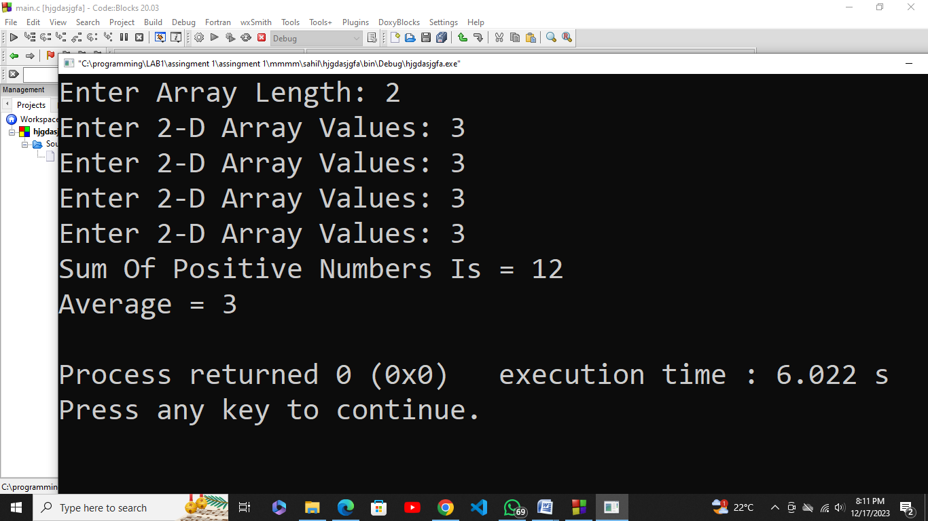

for(a = 0; a < len; a++){

for(b = 0; b < len; b++){

printf("Enter 2-D Array Values: ");

scanf("%d", &arr[a][b]);

if(arr[a][b] > 0){

sum += arr[a][b];

totalnum += 1;

}

}

}

aver = sum / totalnum;

printf("Sum Of Positive Numbers Is = %d\n", sum);

printf("Average = %d\n", aver);

return 0;

}

02. Write a C program to read elements in a matrix and check whether matrix is Sparse matrix or not. Logic: To check whether a matrix is sparse matrix we only need to check the total number of elements that are equal to zero. The matrix is sparse matrix if T ≥ ((m * n) / 2 ) where T defines total number of zero elements where m and n are rows and columns respectively.

#include<stdio.h>

#include<stdlib.h>

int main(){

int row,col,x,y,totalnum = 0;

printf("Enter the number of row: ");

scanf("%d",&row);

printf("Enter the length of Column: ");

scanf("%d",&col);

int arr[row][col];

for(x = 0; x < row; x++){

for(y = 0; y < col; y++){

printf("Enter Element of Matrix: "); **Out put:**

scanf("%d",&arr[x][y]);

}

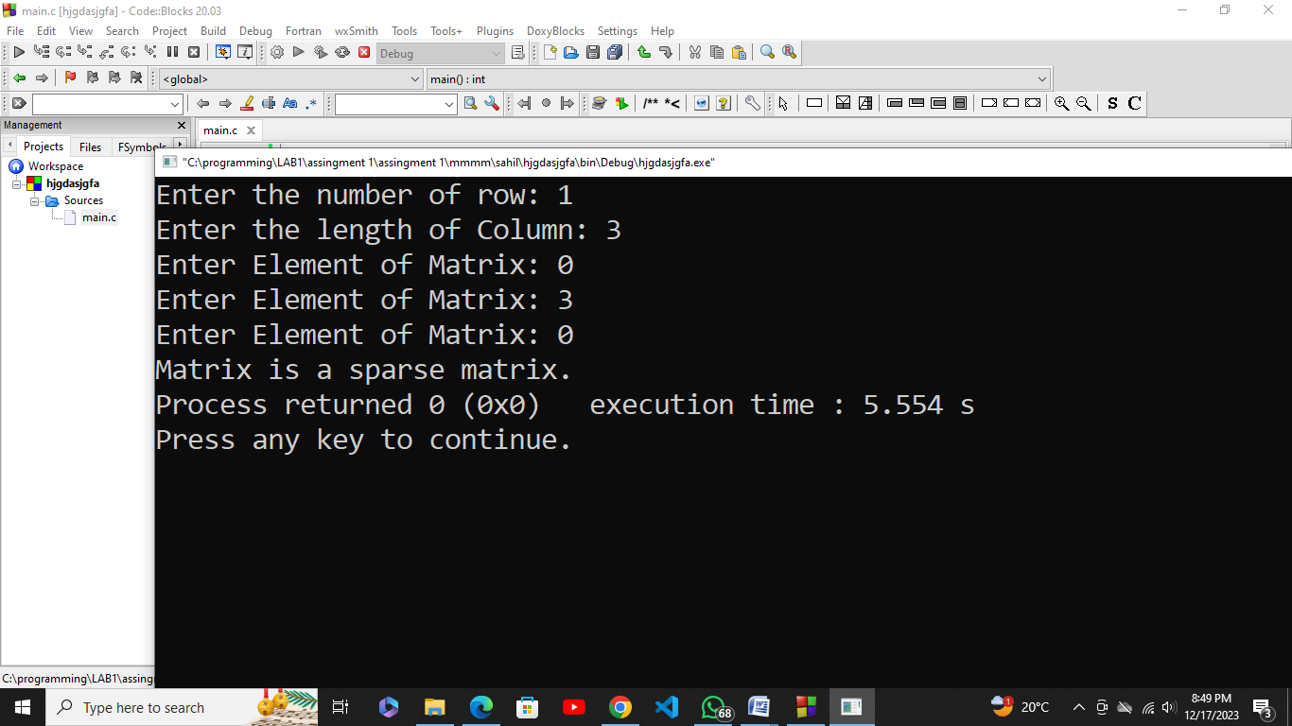

}

for(x = 0; x < row; x++){

for(y = 0; y < col; y++){

if(arr[x][y] == 0)

totalnum += 1;

}

}

int d = row*col/2;

if(totalnum > d)

printf("Matrix is a sparse matrix.");

else

printf("Matrix is not sparse matrix.");

return 0;

}

03. Write down a program which asks user to input his first name and last name in a separate array. After taking the input your program should be able to concatenate first name and last name and return it as full name. Count down number of characters in the full name as well.

For example: First name: Muhammad, Second name: Ahmed, Full name: Muhammad Ahmed

#include<stdio.h>

#include<stdlib.h>

int main() {

char firname[20], lastname[20], fullname[50];

int a = 0, b = 0, lencount = 0;

printf("Enter your first name: ");

scanf("%s", firname);

printf("Enter your last name: ");

scanf("%s", lastname); **Out put:**

while (firname[a]) {

fullname[lencount] = firname[a];

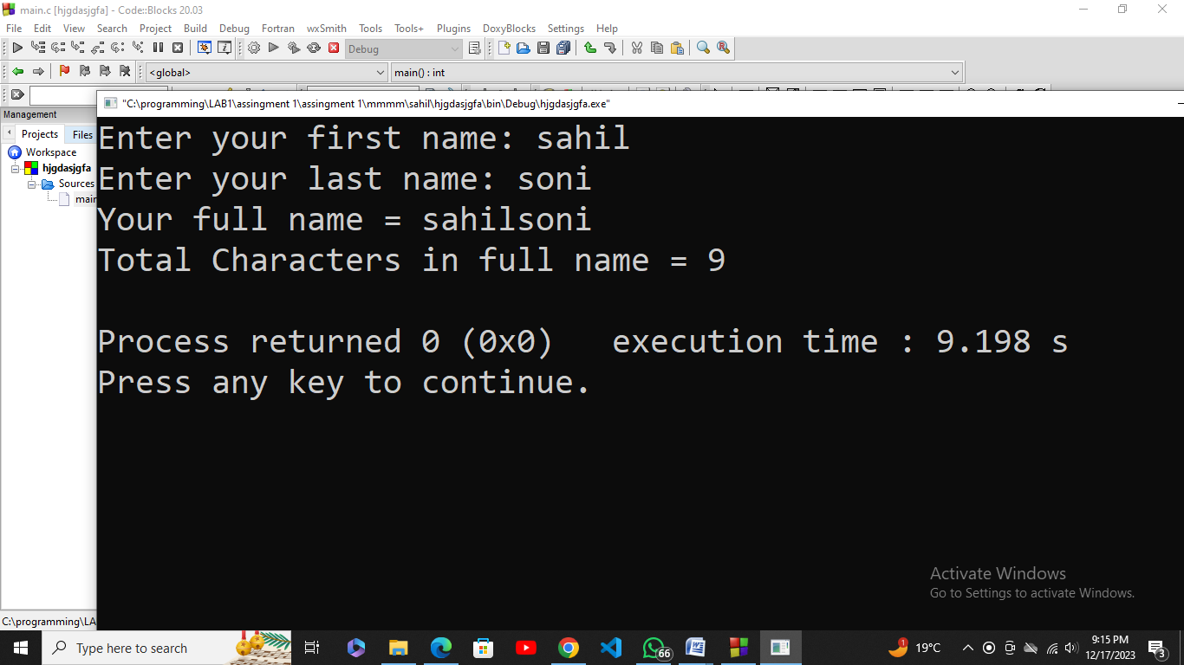

a++;

lencount++;

}

while (lastname[b]) {

fullname[lencount] = lastname[b];

b++;

lencount++;

}

!fullname[lencount];

printf("Your full name = %s\n", fullname);

printf("Total Characters in full name = %d\n", lencount);

return 0;

}

04. You taking a square matrix as input from keyboard and then you transpose the same matrix after meeting the requirements you are also interested to find out whether original Matrix A and transpose of Matrix A are equal are not. If the answer is yes, then you print the matrix along with message “matrix is symmetric” otherwise you print the “matrix is asymmetric”.

#include <stdio.h>

#include<stdlib.h>

void sym() {

int len;

printf("Enter the length of your matrix: ");

scanf("%d", &len);

int transp[len][len], matrx[len][len], symtrc = 0;

for(int i = 0; i < len; i++){

for(int j = 0; j < len; j++){

printf("Enter Value of Matrix: ");

scanf("%d", &matrx[i][j]);

} **Out put:**

}

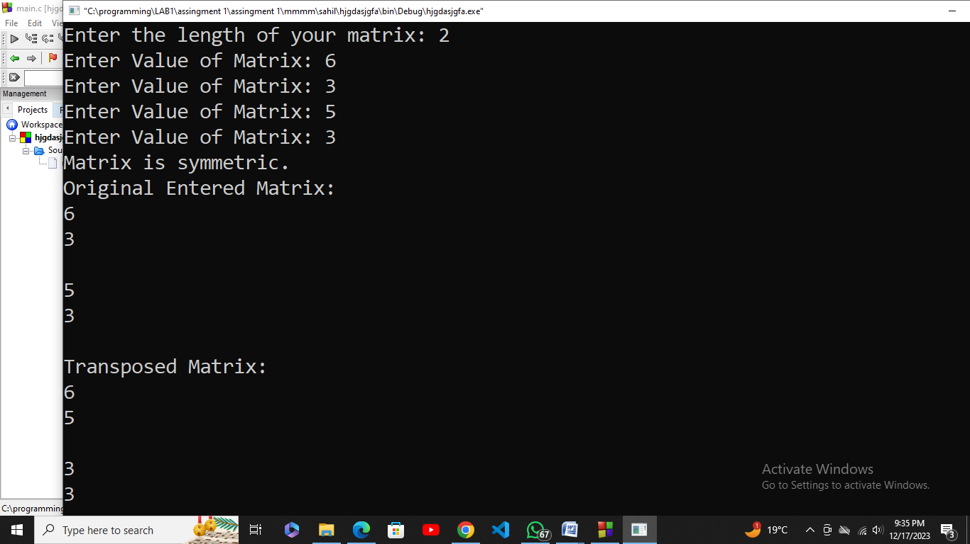

for(int i = 0; i < len; i++){

for(int j = 0; j < len; j++){

transp[j][i] = matrx[i][j];

if(transp[i][j] == matrx[i][j]){

symtrc = 1;

}else{

symtrc = 0;

}

}

}

if(symtrc){

printf("Matrix is symmetric.\n");

}else{

printf("Matrix is asymmetric.\n");

}

printf("Original Entered Matrix:\n");

for(int i = 0; i < len; i++){

for(int j = 0; j < len; j++){

printf("%d\n", matrx[i][j]);

}

printf("\n");

}

printf("Transposed Matrix:\n");

for(int i = 0; i < len; i++){

for(int j = 0; j < len; j++){

printf("%d\n", transp[i][j]);

}

printf("\n");

}

return 0;

}

int main(){

sym();

}

05. Write a program which takes a matrix of any size as user input and returns the maximum element of matrix as output. Your code should also show the entered matrix on the screen.

#include <stdio.h>

#include<stdlib.h>

int main(){

int row, col;

printf("Enter Number Of Rows: ");

scanf("%d", &row);

printf("Enter Number Of Columns: "); **Out put:**

scanf("%d", &col);

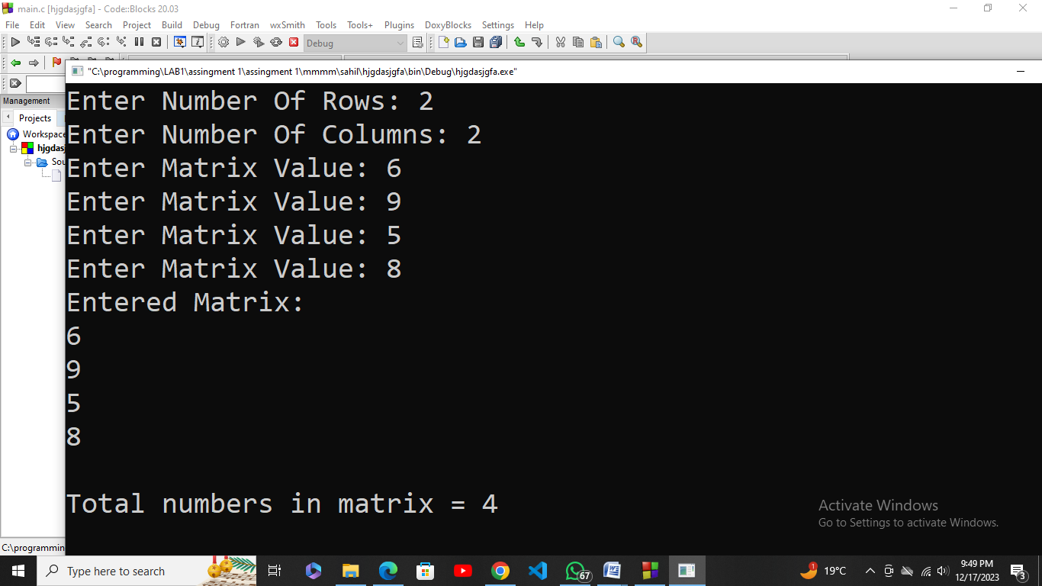

int matrx[row][col];

for(int d = 0; d < row; d++){

for(int e = 0; e < col; e++){

printf("Enter Matrix Value: ");

scanf("%d", &matrx[d][e]);

}

}

int totnmbrs = row * col;

printf("Entered Matrix:\n");

for(int d = 0; d < row; d++){

for(int e = 0; e < col; e++){

printf("%d\n", matrx[d][e]);

}

}

printf("\nTotal numbers in matrix = %d\n", totnmbrs);

return 0;

}